TASK 1:
#include <iostream>
using namespace std;
const int TABLE_SIZE = 10;

class HashNode {
public:
int key;
int data;
HashNode* next;

HashNode(int k, int d) : key(k), data(d), next(NULL) {}
};

class UniqueHashTable {
private:
HashNode** hashTable;

// Double hash function
int doubleHash(int key, int i) {
const int prime = 7;
return (key % TABLE_SIZE + i * (prime - (key % prime))) % TABLE_SIZE;
}

public:
UniqueHashTable() {
hashTable = new HashNode*[TABLE_SIZE]();
}

void insert(int key, int data) {
int index = key % TABLE_SIZE;
int i = 1;
while (hashTable[index] != NULL) {
index = (index + doubleHash(key, i)) % TABLE_SIZE;
i++;
}
hashTable[index] = new HashNode(key, data);
}

HashNode* search(int key) {
int index = key % TABLE_SIZE;
int i = 1;
while (hashTable[index] != NULL) {
if (hashTable[index]->key == key) {
return hashTable[index];
}
// Use double hashing for collision resolution during search as well
index = (index + doubleHash(key, i)) % TABLE_SIZE;
i++;
}
return NULL;
}

void remove(int key) {
int index = key % TABLE_SIZE;
int i = 1;
while (hashTable[index] != NULL) {
if (hashTable[index]->key == key) {
HashNode* temp = hashTable[index];
hashTable[index] = NULL;
delete temp;
return;
}
index = (index + doubleHash(key, i)) % TABLE_SIZE;
i++;
}
}

void display() {
for (int i = 0; i < TABLE_SIZE; i++) {
cout << "Index " << i << ": ";
if (hashTable[i] != NULL) {
HashNode* current = hashTable[i];
while (current != NULL) {
cout << "(" << current->key << ", " << current->data << ") ";
current = current->next;
}
}
cout << endl;
}
}

~UniqueHashTable() {
for (int i = 0; i < TABLE_SIZE; i++) {
HashNode* current = hashTable[i];
while (current != NULL) {
HashNode* temp = current;
current = current->next;
delete temp;
}
}
delete[] hashTable;
}
};

int main() {
UniqueHashTable uniqueHashTable;

uniqueHashTable.insert(20, 200);
uniqueHashTable.insert(34, 340);
uniqueHashTable.insert(45, 450);
uniqueHashTable.insert(70, 700);
uniqueHashTable.insert(56, 560);

cout << "Initial Hash Table:\n";
uniqueHashTable.display();

int searchKey = 45;
HashNode* searchData = uniqueHashTable.search(searchKey);
if (searchData != NULL) {
cout << "Element with key " << searchKey << " found: (" << searchData->key << ", " << searchData->data << ")\n";
} else {
cout << "Element with key " << searchKey << " not found.\n";
}

int deleteKey = 70;
uniqueHashTable.remove(deleteKey);
cout << "\nAfter deleting element with key " << deleteKey << ":\n";
uniqueHashTable.display();

return 0;
}

OUTPUT:
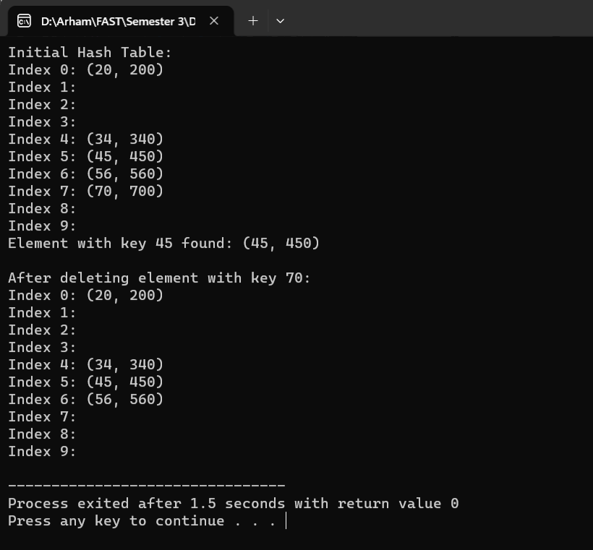

TASK 2:
#include <iostream>
using namespace std;
const int MAX_SIZE = 100000;

class HashTable {
private:
struct Node {
int key;
int count;
Node* next;

Node(int k) : key(k), count(1), next(NULL) {}
};

Node* table[MAX_SIZE];

int hash(int key) {
return key % MAX_SIZE;
}

public:
HashTable() {
for (int i = 0; i < MAX_SIZE; i++) {
table[i] = NULL;
}
}

void insert(int key) {
int index = hash(key);
Node* newNode = new Node(key);

if (table[index] == NULL) {
table[index] = newNode;
} else {
Node* current = table[index];
while (current->next != NULL) {
current = current->next;
}
current->next = newNode;
}
}

// Count the number of occurrences of a key in the hash table
int count(int key) {
int index = hash(key);
Node* current = table[index];

while (current != NULL) {
if (current->key == key) {
return current->count;
}
current = current->next;
}

return 0; // Key not found
}

void incrementCount(int key) {
int index = hash(key);
Node* current = table[index];

while (current != NULL) {
if (current->key == key) {
current->count++;
return;
}
current = current->next;
}
}

~HashTable() {
for (int i = 0; i < MAX_SIZE; i++) {
Node* current = table[i];
while (current != NULL) {
Node* temp = current;
current = current->next;
delete temp;
}
}
}
};

int PairsWithSum(int arr[], int N, int K) {
HashTable hashTable;

int countPairs = 0;

for (int i = 0; i < N; i++) {
int complement = K - arr[i];

countPairs += hashTable.count(complement);

hashTable.incrementCount(arr[i]);

hashTable.insert(arr[i]);
}

return countPairs;
}

int main() {
int arr[] = {2, 9, 7, 4, 5, 6, 10, 0};
int N = 8;
int K = arr[0]+arr[1];

int result = PairsWithSum(arr, N, K);

cout << "Number of pairs with sum " << K << ": " << result << endl;

return 0;
}
OUTPUT:
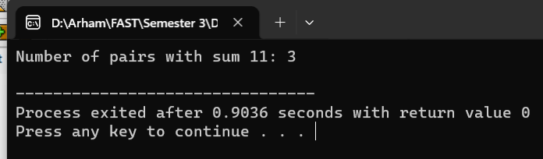

TASK 3:
#include <iostream>
#include <cmath>
using namespace std;
const int MAX_SIZE = 100000;

class HashTable {
private:
struct HashNode {
int key;
HashNode* next;

HashNode(int k) : key(k), next(nullptr) {}
};

HashNode* table[MAX_SIZE];

int hash(int key) {
// Ensure non-negative hash values
return (key % MAX_SIZE + MAX_SIZE) % MAX_SIZE;
}

public:
HashTable() {
for (int i = 0; i < MAX_SIZE; i++) {
table[i] = nullptr;
}
}

void insert(int key) {
int index = hash(key);
HashNode* newNode = new HashNode(key);

if (table[index] == nullptr) {
table[index] = newNode;
} else {
HashNode* current = table[index];
while (current->next != nullptr) {
current = current->next;
}
current->next = newNode;
}
}

// Check if a key exists in the hash table
bool contains(int key) {
int index = hash(key);
HashNode* current = table[index];

while (current != nullptr) {
if (current->key == key) {
return true;
}
current = current->next;
}

return false;
}

~HashTable() {
for (int i = 0; i < MAX_SIZE; i++) {
HashNode* current = table[i];
while (current != nullptr) {
HashNode* temp = current;
current = current->next;
delete temp;
}
}
}
};

int ZeroTriplets(int arr[], int n) {
for (int i = 0; i < n - 1; i++) {
HashTable hashTable;

for (int j = i + 1; j < n; j++) {
int complement = -(arr[i] + arr[j]);

// Check if the complement exists in the hash table
if (hashTable.contains(complement)) {
return 1;
}

hashTable.insert(arr[j]);
}
}

return 0;
}

int main() {
int arr[] = {0, -1, 2, -3, 1};
int n = 5;

int tripletExists = ZeroTriplets(arr, n);

cout << "Output: " << tripletExists << endl;

return 0;
}

OUTPUT:
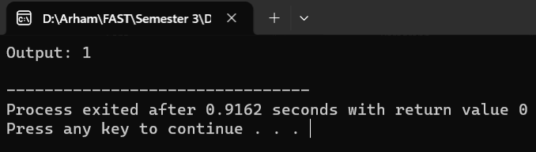

TASK 4:
#include <iostream>
using namespace std;
class NutBoltMatcher {
private:
char order[8] = {'#', '$', '%', '&', '*', '@', '^', '~'};

// Partition the bolts based on the pivot nut
int partition(char bolts[], int low, int high, char pivot) {
int i = low - 1;

for (int j = low; j < high; j++) {
if (bolts[j] < pivot) {
i++;
swap(bolts[i], bolts[j]);
} else if (bolts[j] == pivot) {
swap(bolts[j], bolts[high]);
j--;
}
}

swap(bolts[i + 1], bolts[high]);
return i + 1;
}

// Use the last bolt as a pivot to partition nuts
int partitionNuts(char nuts[], int low, int high, char pivot) {
int i = low - 1;

for (int j = low; j < high; j++) {
if (nuts[j] < pivot) {
i++;
swap(nuts[i], nuts[j]);
} else if (nuts[j] == pivot) {
swap(nuts[j], nuts[high]);
j--;
}
}

swap(nuts[i + 1], nuts[high]);
return i + 1;
}

// Perform quicksort on nuts and bolts
void matchHelper(char nuts[], char bolts[], int low, int high) {
if (low < high) {

int pivotIndex = partitionNuts(nuts, low, high, bolts[high]);

partition(bolts, low, high, nuts[pivotIndex]);

matchHelper(nuts, bolts, low, pivotIndex - 1);
matchHelper(nuts, bolts, pivotIndex + 1, high);
}
}

public:
// Match nuts and bolts
void match(char nuts[], char bolts[], int n) {
matchHelper(nuts, bolts, 0, n - 1);
}

// Display the matched nuts and bolts
void display(char arr[], int n) {
for (int i = 0; i < n; i++) {
cout << arr[i] << " ";
}
cout << endl;
}
};

int main() {
NutBoltMatcher matcher;

char nuts[] = {'@', '%', '$', '#', '^'};
char bolts[] = {'%', '@', '#', '$', '^'};
int n = 5;

matcher.match(nuts, bolts, n);

cout << "Matched nuts: ";
matcher.display(nuts, n);

cout << "Matched bolts: ";
matcher.display(bolts, n);

return 0;
}
OUTPUT:
